# Describe briefly each Layer of OSI 7 Layers?

Physical layer: Deals with standardizing how two computers are connected and how 0s and 1s are represented.

Data link layer: Provides the means to detect and possibly correct transmission errors, as well as protocols to keep a sender and receiver in the same pace.

Network layer: Contains the protocols for routing a message through a computer network, as well as protocols for handling congestion.

Transport layer: Mainly contains protocols for directly supporting applications, such as those that establish reliable communication, or support real time streaming of data.

Session layer: Provides support for sessions between applications.

Presentation layer: Prescribes how data is represented in a way that is independent of the hosts on which communicating applications are running.

Application layer: Essentially, everything else: e-mail protocols, Web access protocols, file-transfer protocols, and so on.

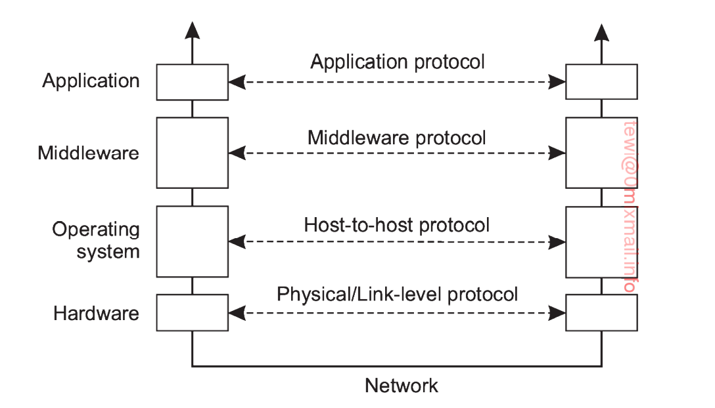

# What is the RPC Remote procedure call?

RPCs allow programs to call procedures located on other machines. When a process on machine A calls a procedure on machine B, the calling process on A is suspended, and execution of the called procedure takes place on B. Information can be transported from the caller to the callee in the parameters and can come back in the procedure result. No message passing at all is visible to the programmer. 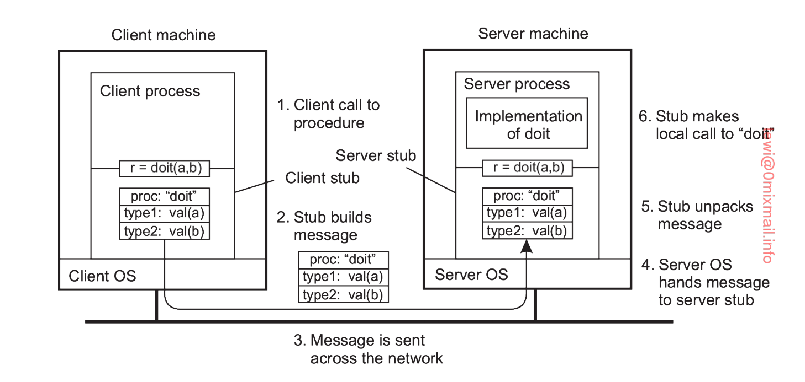

# What are the Middleware Protocols?

Middleware is an application that logically lives (mostly) in the OSI application layer, but which contains many general-purpose protocols that warrant their own layers, independent of other. Like DNS

# What is the Persistent Communication?

A message that has been submitted for transmission is stored by the communication middleware as long as it takes to deliver it to the receiver. In this case, the middleware will store the message at one or several of the storage facilities.

# What is the transient communication?

A message is stored by the communication system only as long as the sending and receiving application are executing.

# What is the characteristic of asynchronous communication?

The characteristic feature of asynchronous communications that a sender continues immediately after it has submitted its message for transmission. This means that the message is (temporarily) stored immediately by the middleware upon submission.

# What is the characteristic of Synchronous communication?

With synchronous communication, the sender is blocked until its request is known to be accepted.

# What is the REST API?

The term REST stands for Representational State Transfer. It is an architectural style that defines a set of rules in order to create Web Services. In a client server communication, REST suggests creating an object of the data requested by the client and send the values of the object in response to the user.

Use the Http 1.1 Half duplex protocol to use its actions {Post, Get, Put, Delete}

To provide a standard for the business action of CRUD operatons

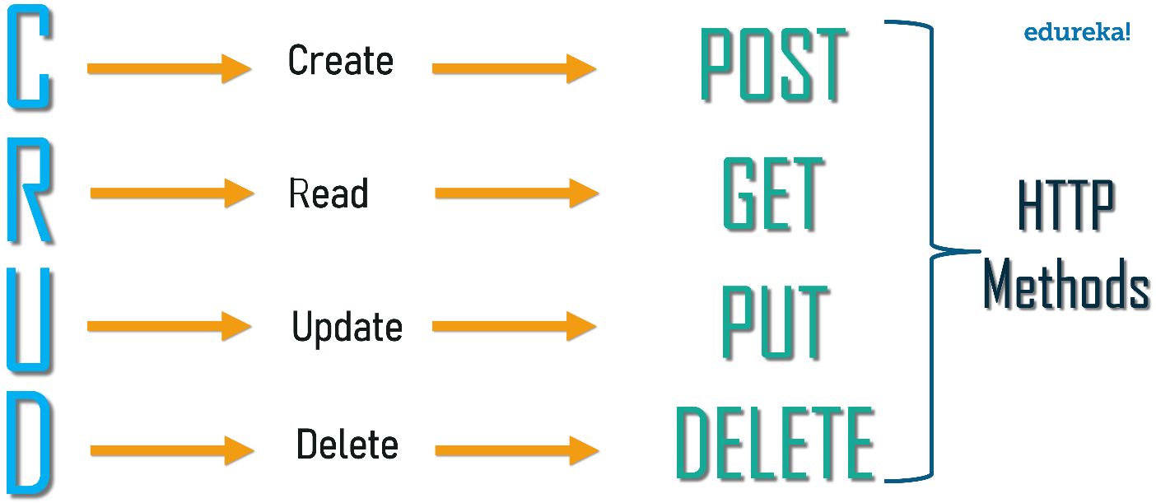

# What is the gRPC The New version of RPCs?

gRPC is a modern open-source high performance Remote Procedure Call (RPC) framework that can run in any environment, that uses Http2.0 full duplex protocol so it can work in real time behavior.

gRPC was initially created by Google and published in 2016, which has used a single general-purpose RPC infrastructure called **Stubby** to connect the large number of **microservices** running within and across its data centers for over a decade.

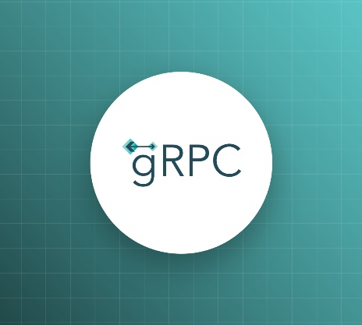

# Compare between different Communication Architecture technologies and describe their timeline?

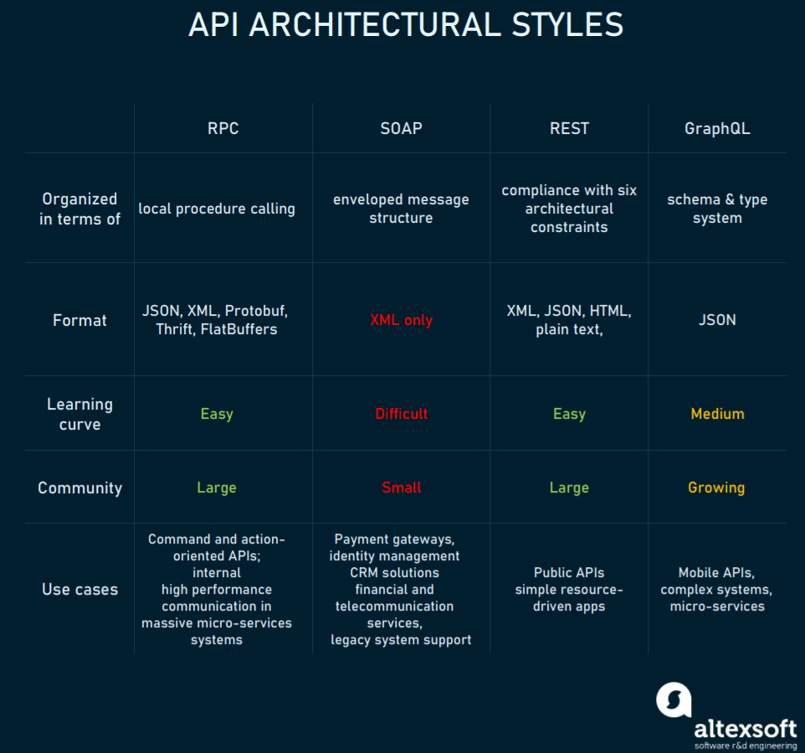

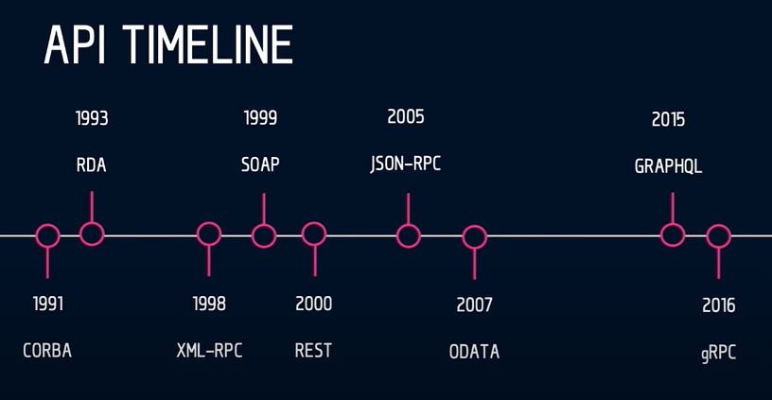

11 – What is the protocol used in REST APIs?

1. AMQP b- HTTP 1.0 c- MQTT d- HTTP 1.1

Answer: d- HTTP 1.1

12 – What is the protocol used in gRPC?

1. AMQP b- HTTP 2.0 c- MQTT d- HTTP 1.1

Answer: b- HTTP 2.0

13 – gRPCs is created by _____________ to connect large number of microservices?

1. Google b- Microsoft c- Facebook d- IBM

Answer: a- Google

14 – GraphQL is created by _____________ to give a rich language for calling services ?

1. Google b- Microsoft c- Facebook d- IBM

Answer: c- Facebook

15 – The most used protocol for messages queuing ?

1. AMQP b- HTTP 2.0 c- MQTT d- HTTP 1.1

Answer: a- AMQP

16 – What is the Design Pattern really support using messages queuing?

1. Pub/Sub b- observer c- state d- command

Answer: a- pub/sub

17- allows an application to set up a connection to a queue manager; a connection is a container for a number of one-way channels.

1. AMQP b- HTTP 2.0 c- MQTT d- HTTP 1.1

Answer: a- AMQP

18- measures the ratio in the delay between two nodes in the overlay, and the delay that those two nodes would experience in the underlying network.

1. AMQP b- RDP c- MQ d- MQTT

Answer: b- RDP

19 - An example of how we can effectively use knowledge of the structure of an overlay network to establish efficient flooding.

1. Rumor b- Singlecube c- Hypercube d- Gossiping

Answer: c- Hypercube

20 – technique used for disseminating information is to rely on epidemic behavior

1. Rumor b- Singlecube c- Hypercube d- Gossiping

Answer: d- Gossiping